Bali Tour Guide – November 2024
Itinerary 4 Nights (03-Nov to 06-Nov-2024)
Day-01 | 03-Nov-2024 / Sunday

Apply for Bali Visa on Arrival (e-VOA) online
https://ecd.beacukai.go.id/

Bali Tourist tax of 150,000 rupiah (S$12.60)
https://lovebali.baliprov.go.id/

From the Airport & transfer to directly to SANUR Harbor.
- Estimate arrival to Airport: 10:00am & Immigration clearance and out by 11am
- TAXI booked from Airport to Sanur Harbour
- Pick-up the Taxi from Airport and reach Sanur Harbour around 12:30pm
- Plan for the Lunch around the Sanur
- Take the fast boat start 1pm & reach to Nusa Penida Island Harbour around 2pm

Across using PUBLIC fast boat to Nusa Penida Island (it takes approx. 45 minutes).
Upon arrive at NUSA PENIDA Island will be plan reach to the Hotel.

Name of Hotel | The Angkal Resort  Ocean View Room
Contact Number | +62 831-1985-6715
Address | Banjar Angkal, Desa Suana Nusa Penida Island-Klungkung,  80771 Nusa Penida, Indonesia
Pickup from Harbour (FREE)
Drop to Harbour (FREE)
Payment | Full payment at the property upon your arrival (confirmed)

Day-02 | 04-Nov-2024 / Monday

D2. ONE DAY TRIP to NUSA PENIDA ISLAND (West Island Tour)
Check out from NUSA PENIDA Hotel and Start the Tour to visit :
- “Angel Billabong” offers a majestic view as one of Nusa Penida’s mystery getaway as well as a magnificent infinity pool.
- Just a minute walk from Angle Billabong, you will reach in “Broken Beach (Pantai Pasih Uug), You will find the remains of what once a massive cave, a spectacular place which is definitely one of the best place to see in Nusa Penida.
- Drive to a local restaurant for having Indonesian set menu lunch,
- After lunch, depart to Kelingking Beach Secret Point, which is probably the most photographed section as the view from the cliff is simply beautiful. Once you gaze off to the stones cliff that looks like a dinosaur chilling by the beach.
- Depart to Crystal Bay, enjoy a clear water and it is also a great place to snorkel and enjoy the rich marine life, Please bring swim-suits.
- Finally back to Buyuk Penida pier to catch your fast boat back to Bali.
- Upon arrival in Sanur beach, you will be transferred back to your hotel. (L)
Name of Hotel | Campuhan Sebatu Resort  Junior Suite with Balcony
Contact Number | +62 361 9081891
Address | Jalan Uma Kelod, Sebatu, Tegalalang, Ubud, Bali, Indonesia, 80571 Tegalalang, Indonesia
Pickup from
Drop to
Payment | Debit on 30-Oct-2024 from Card

Day-03 | 05-Nov-2024 / Tuesday

D3. After breakfast, Tour starts at 08.00am :
Full day KINTAMANI VOLCANO Tour, visit Traditional handmade BATIK PAINTING in Batubulan Village, visit PAINTING and WOOD CARVING at MAS village, continue to a highland to visit COFFEE PLANTATION Enjoy guided tour around Coffee Plantation and get educated information about coffee plantation and some others plantations like chocolate and some Balinese herbs. In this place you can also witness the traditional process of making the Civet Coffee.
The Highlight is to see nice view of MOUNT BATUR & and its sister LAKE BATUR,
on the way back visit to UBUD HANDICRAFT VILLAGE.
Shopping places are available on this tour and You may spend your time for shopping of any kind of Balinese handicraft products good for souvenir and or for collection. (-)
Name of Hotel | Hotel Nikko Bali Benoa Beach  Deluxe Room
Contact Number | +62 361 773577
Address | Jl. Pratama No 68X, 80363 Nusa Dua, Indonesia
Pickup from
Drop to
Payment | Full payment paid on 24-Oct-2024 confirmed

Day-04 | 06-Nov-2024 / Wednesday

D4. After breakfast, at 08.00am depart from hotel :
depart to GARUDA WISNU KENCANA CULTURAL PARK (GWK + BUGGY) The main feature of the park is the 125 meters tall statue of the Hindu God, Wisnu, riding on the wings of a golden Garuda eagle, which is visible from a 10km radius. This cultural park has some facilities such as Exhibition hall, Amphitheatre, Street theatre, Lotus Pond, Café and Restaurants. Those are used mostly for BIG FUNCTIONS, theme night dinners, farewell party, product launching, heavy cocktail party, wedding ceremony and reception, tea time etc.
Continue to visit : ULUWATU TEMPLE TOUR. Visit to ancient Hindu temple located on top of the cliff jutting out to the ocean over 100 meters above the sea level. It is a spectacular view from the splash of the wave all the times under the natural rocky cliff. Many holy monkeys around the temple courtyard which is believed as guardian of the temple. (-)
Name of Hotel | Discovery Kartika Plaza Hotel  Deluxe Double or Twin Room with Garden View
Contact Number | +62 361 2001300
Address | Jl. Kartika Plaza, P.O Box 1012, South Kuta Beach, 80361 Kuta, Indonesia
Pickup from
Drop to
Payment | Full payment paid on 14-Oct-2024 confirmed

Day-05 | 07-Nov-2024 / Thursday

D5. After breakfast. Free arrangement and departure transfer to Airport (-).
**Passengers travelling to BALI, are now required to pay Bali TOURISM LEVY of IDR 150.000,- per person, to be paid directly at the Tourism Levy counter at Bali Airport.
Hotel Used
RISATA BALI RESORT, KUTA, 4 star hotel, Superior room / ASTON KUTA & RESIDENCE, KUTA, 4 star hotel, Superior room
STAR SEMABU RESORT, NUSA PENIDA, Deluxe Ocean View Room

DISCOVERY KARTIKA PLAZA HOTEL, 5 star hotel on the beach side, Deluxe Garden View

SEMABU HILLS NUSA PENIDA Grand Deluxe Room Garden View

Package Cost Per Person Rs.35900+ Air Fare

Day | Location | Activities | Hotel | Viewing Place | Remarks  Price for 2
03-Nov-2024  Sunday | Arrived 10am |  | SEMABU HILLS NUSA PENIDA |  | S$82 per Nite
04-Nov-2024
Monday
05-Nov-2024
Tuesday
06-Nov-2024
Wednesday
07-Nov-2024
Thursday
 | To Airport

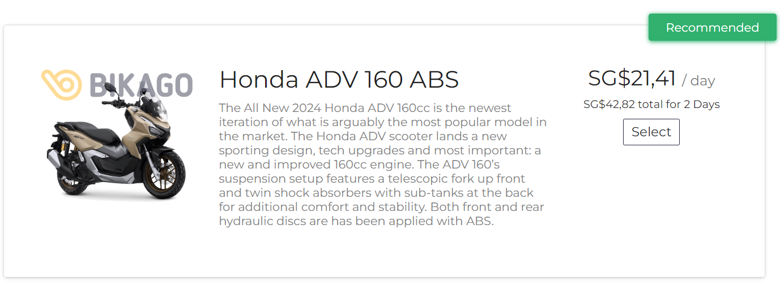
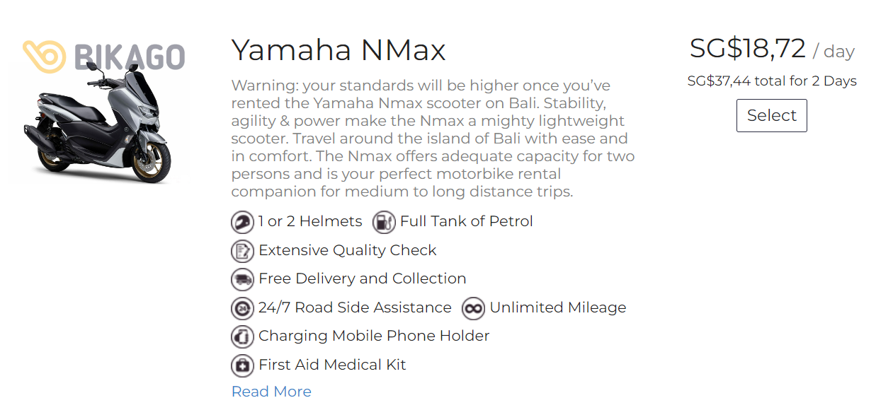

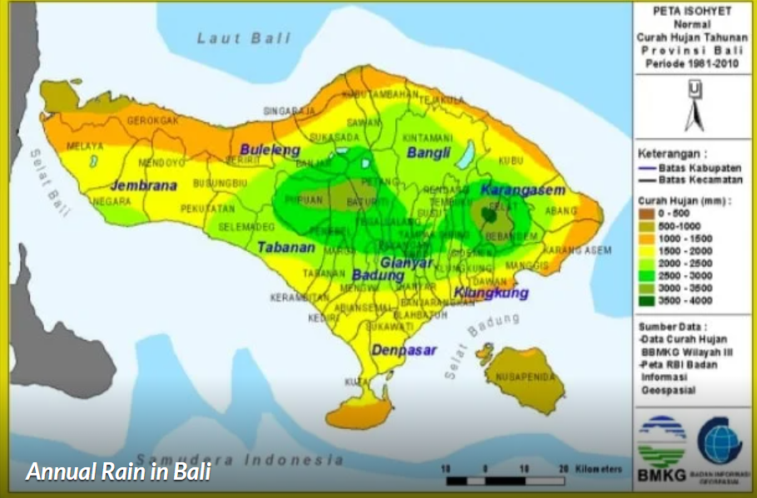
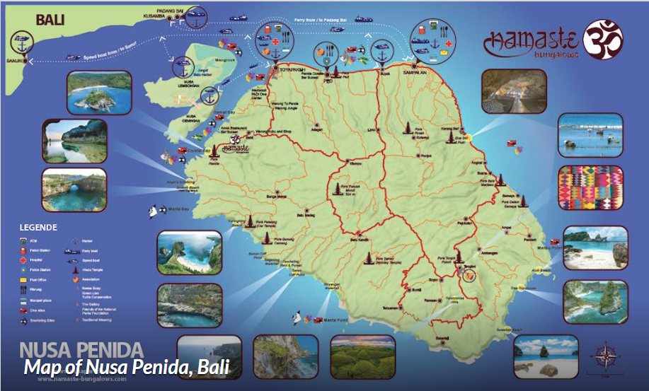

https://www.bookaway.com/

